main = "main" — this branch contains stable, production-ready code.
dev = "dev" — this branch is used to test and integrate new features before they are promoted to main.
feature branches = "feature/<name>" — these branches are used for developing individual features.
TASK 2
Company A — Small Startup
Team:
- 1 Backend
- 1 Frontend
- 1 DevOps
Since we have One product, Small team and Simple workflow for easy collaboration.
A1) Therefore we will go for one monorepo.
A2) It may contain or should I say the structure could be like this
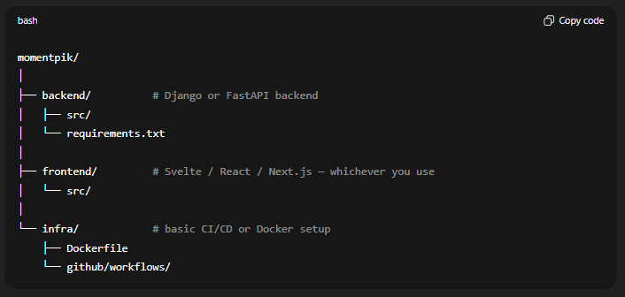
A4) Our Branching Strategy will be Simple
Only 3 layers (beginner-friendly):
1) main
- Production-ready
- Stable code
- Protected branch
2) dev
- Testing / integration branch
- All features merge here first
3) feature branches
Pattern:
feature/<feature-name>
Examples:
feature/navbar-ui
feature/login-api
feature/photoCard-logic
A3) Naming Conventions
Use lowercase with hyphens:
- backend
- frontend
- infra
Feature branches:
- feature/user-auth
- feature/navbar-ui
Consistent + clean = easier collaboration.

Repo design for Medium Org (B)
A1) Number of Repos
The company has multiple microservices + separate infrastructure, so we create 4 repos:
- auth-service
- payment-service
- order-service
- infra-terraform

A2) Microservice Repo Structure (Python + Docker + CI/CD)
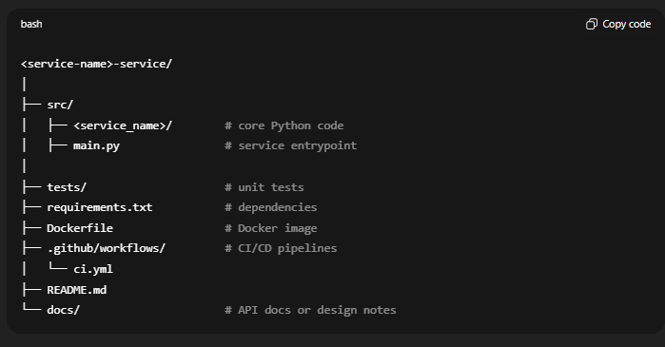
Why this structure?
- /src → clean, standard Python layout
- /tests → isolation of unit tests
- Dockerfile → containerization
- .github/workflows → GitHub Actions CI/CD
- README.md → onboarding developers
- docs/ → service-specific documentation

A3) Terraform (Infrastructure Provisioning)
I will chose Terraform Because it is used to create cloud resources, such as:
- Virtual machines
- Databases
- Networks
- Load balancers
- Kubernetes clusters
like:
“I want 3 servers, 1 database, and a network in AWS. Terraform, build this.”
While from my understand Ansible is a Configuration Management. So why we going to use for infrastructure repo. It does not make sense to me?
Ansible is used to configure servers, such as:
- Installing software
- Updating packages
- Managing users
- Running scripts
- Configuring applications
Ansible is like:
“I already have servers, now set them up.”

Repo name:
infra-terraform
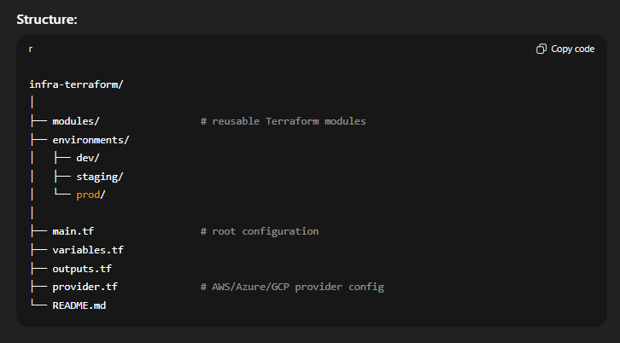

A4) Branch Protection Rules (Company B)
Each repo (microservice + infra) should enable:
- Protect main branch
  - No direct pushes
  - Only PRs allowed
- Require PR before merge
  - Enforces review process
- Require 1–2 reviewers
  - Ensures code quality
- Require CI to pass
  - Cannot merge failing builds
- Require status checks
  - Linting
  - Unit Tests
  - Security scan
A5) Basic GitHub Policies to Enable
- Require pull request before merging
- Require at least 1 reviewer
- Require status checks before merge (CI must pass)

